

**Tafila Technical University**

**Faculty of Engineering**

**Department of Computer Engineering and Communication**

**Design and Construction of an Electric Wheelchair**

A Graduation project Dissertation by:

|  |  |
| --- | --- |
| STUDENTS NAMES | STUDENTS ID’S |
| Allaith Alrbeihat | 320200112156 |
| Mohammed Alakayla | 320200112154 |
| Mohammed Eyal Salman | 320200112158 |
| Feras Mustafa | 320200112089 |
| Subhi kurdia | 320200112106 |
| Malek Ghaith | 320200112014 |
| SUPERVISED BY: DR. ABDEL LLAH ALSHBATAT | |

This project was submitted for the requirements of a bachelor's degree in Intelligent System Engineering, Tafila Technical University

**Acknowledgement**

First and foremost, we express our gratitude and praise to the Almighty God, who has bestowed upon us wisdom and knowledge, and made us seekers of understanding. We would like to extend our sincere appreciation to all those who have provided advice, guidance, and assistance in the completion of this research. In particular, we would like to thank **Dr. Abdel llah Shabatat** for his unwavering support and invaluable guidance. His contributions have been instrumental to our success. We would also like to acknowledge the efforts of Tafila Technical University in creating a conducive study environment and providing us with the necessary resources and services. Their dedication to the welfare of students is greatly appreciated. We are grateful to everyone who has played a role, directly or indirectly, in the development of this project. Your contributions have been invaluable.

**Table of Contents:**

|  |  |
| --- | --- |
| **Contents:** | **Page No.** |
| Abstract | 4 |
| Introduction | 4 |
| Literature Review | 5 |
| Project Overview | 5 – 7 |
| Flow Chart | 8 |
| Project Plan | 9 |
| Design (Hardware and Software) | 10 |
| Implementation (Hardware and Software) | 10 – 12 |
| Conclusion | 13 |
| References | 14 |

**List of Tables:**

|  |  |
| --- | --- |
| **Tables:** | **Page No.** |
| Command Mapping SpeakUp Click | 8 |
| Connections SpeakUp Click | 8 |

**List of Figures:**

|  |  |
| --- | --- |
| **Figures:** | **Page No.** |
| 1. Joystick Shield | 6 |
| 1. SpeakUp Click Software interface | 7 |
| 1. SpeakUp Click Module | 7 |
| 1. BSS138 FETs | 7 |
| 1. Flow Chart | 8 |
| 1. Project Design | 10 |

**Abstract:**

This project focuses on the design and construction of an electric wheelchair capable of moving in any direction and speed using both a joystick controller and voice commands. The system features an average filter to enhance joystick responsiveness, with an Arduino Mega serving as the main processor to control wheel rotation. Direction and speed are calculated using the resultant vector of the joystick's analog inputs. Additionally, a GPS module has been integrated as a preliminary step for future implementation of computer vision, aiming to further enhance navigation and autonomy. This design seeks to provide greater flexibility and ease of use, with potential future upgrades to improve the user experience.

**Introduction**

The aim of this project is to assist people with disabilities by facilitating their mobility. The project targets individuals who have difficulty walking, specifically those who are paralyzed individuals, amputees, or those with mobility issues, by offering a system that allows movement control through a joystick and voice commands. The **joystick** is used to control the wheelchair's motors, enabling users to move in any direction and at varying speeds. Additionally, the **Speak Up Click** component is utilized to receive voice commands, offering an alternative way to control the wheelchair, particularly for users who may find it difficult to use a joystick.

The system also integrates a **GPS** module to track the wheelchair's current location, laying the foundation for future enhancements like computer vision to assist individuals with Alzheimer's disease in navigating and returning home. In this project, we focused on preparing the GPS environment for future use, ensuring that it can easily accept specific locations to be set as "home" and assigned to one of the buttons for quick access.

As part of the initial development, we tested the GPS system with a start and stop button, allowing the wheelchair to set and track the current location as a target point. When the wheelchair moves away from the target point, the motors start rotating, and when it returns to the target location, the motors stop. This is a preparatory step towards incorporating more advanced features, with the potential for further developments in the future.

**Literature Review:**

* **Design of a Wheelchair for People with Disabilities Controlled by Head Movements**
* This project aims to provide a wheelchair for people with disabilities who face mobility challenges. The wheelchair is controlled by head movements or voice commands using a Bluetooth device. This design offers various control methods, including voice interaction.

[ References: 1]

* **Seeing individuals with disabilities struggling in society highlights the need for a more advanced wheelchair that can significantly improve their quality of life.**

**Project Overview**

**1. Joystick Shield:**

* **Description**: The Arduino joystick shield includes a joystick module and several buttons. In this project, the joystick controls the motors, allowing forward, backward, left, and right movement.

[ References: 2,3,4]

* **Data Flow**: The joystick sends analog signals reflecting the desired movement direction, which are processed by the Arduino to control motor speed and direction.
* **Buttons**:
* **Safety Button**: Stops the motors when activated, preventing movement whether using the joystick or voice commands.
* **Reactivation Button**: Re-enables motor operation after the safety button is deactivated.
* **GPS Control Buttons**: One button stops GPS tracking, and the other reactivates it, setting the current location as the target point. In this project, the initial location at program start is used as the target for demonstration.

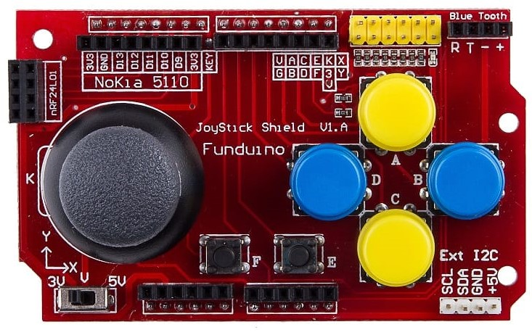

Figure 1 : Joystick Shield

2. **SpeakUp Click Module:**

* **Description**: This module processes voice commands, converting sound waves into digital signals compatible with the Arduino. [ References: 5]
* **Data Flow**: Voice commands are received and processed by the SpeakUp Click module, which sends the appropriate signals to the Arduino via a logic level converter using **BSS138 FETs** to ensure voltage compatibility.
* **SpeakUp Click Software**: A dedicated software is used to configure the module, allowing the recording of voice commands and the assignment of specific digital output signals.

|  |  |  |  |  |
| --- | --- | --- | --- | --- |
| **Voice Command** | **IO1** | **IO2** | **Motor A** | **Motor B** |
| Go | HIGH | HIGH | PWM (100), 4.7V (39%) | PWM (100), 4.7V (39%) |
| Right | HIGH | LOW | PWM (50), 2.3V (19%) | PWM (100), 4.7V (39%) |
| Left | LOW | HIGH | PWM (100), 4.7V (39%) | PWM (50), 2.3V (19%) |
| Stop | LOW | LOW | PWM (0), 0V | PWM (0), 0V |

* **Command Mapping SpeakUp Click**:
  + **Go**: IO1 activated (HIGH), IO2 deactivated (LOW).
  + **Stop**: Both IO1 and IO2 deactivated (LOW).
  + **Right**: IO1 activated (HIGH), IO2 deactivated (LOW).
  + **Left**: IO1 deactivated (LOW), IO2 activated (HIGH).
* **Connections SpeakUp Click:**

|  |  |
| --- | --- |
| **Component** | **Arduino Mega** |
| SpeakUp Click VCC | 5V |
| SpeakUp Click GND | GND |
| SpeakUp Click TX | RX 2(Pin 17) |
| SpeakUp Click RX | TX 2(Pin 16) |
| IO1 (Output) | Pin 7 |
| IO2 (Output) | Pin 8 |

Figure 2 : SpeakUp Click Software

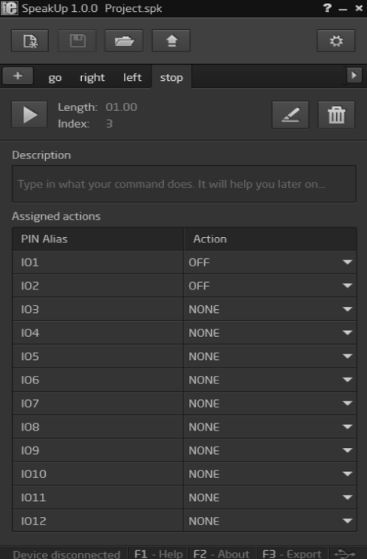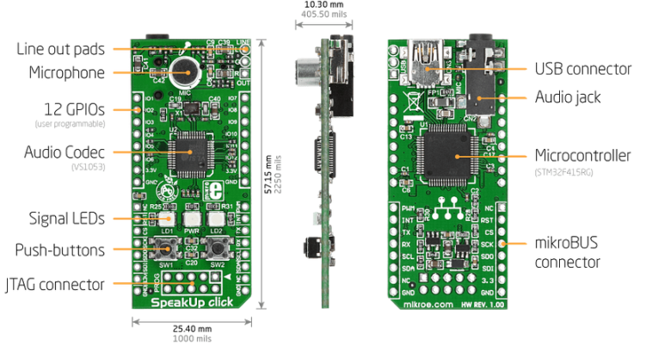

Figure 3 : SpeakUp Click Module

Figure 2: SpeakUp Click Software interface

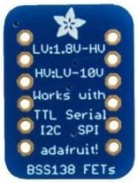

Figure 4 : BSS138 FETs

3. **GPS Module (Neo-6M):**

* **Description**: The GPS module provides current location data and is used to set a fixed location, such as a home. In this project, the NMEA protocol is used to convert the data into UTM coordinates. [ References: 6]
* **Data Flow**: GPS signals are received and converted into Easting and Northing coordinates, allowing the current location to be compared with the predefined target.
* **Future Application**: GPS data can be integrated with computer vision technologies to assist users in returning to fixed locations like their homes.

**Flow Chart**

Figure 5 : Flow Chart

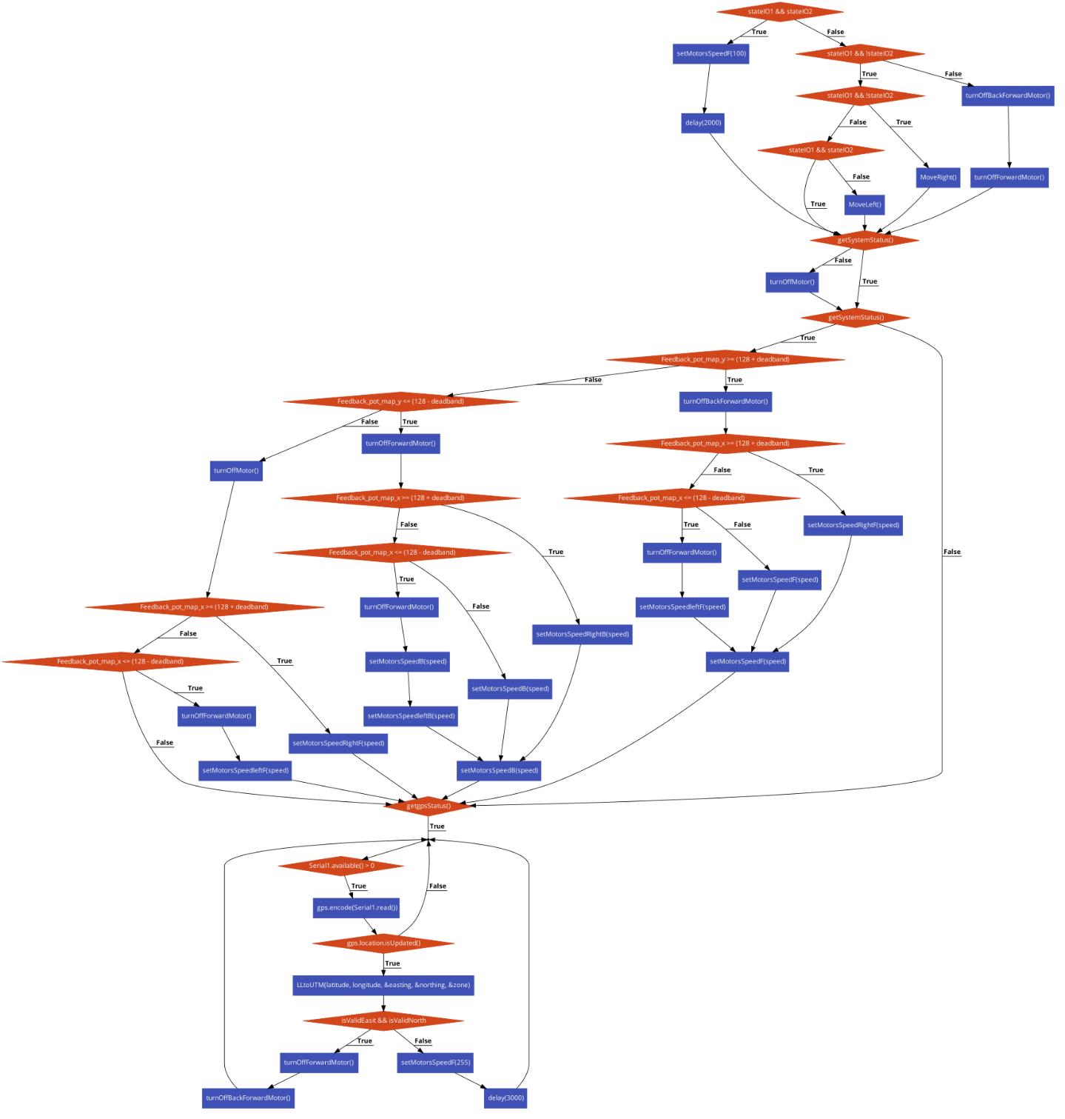**https://app.code2flow.com/dOc3jB8qRyZA**

**Project Plan:**

1. **Design Phase: Group Tasks and Requirement**

***Task*:** Distributing the project to groups and understanding what is required from the group

***Start:*** 13 / 10 / 2024

***End:*** 20 / 10 / 2024

1. **Component Purchasing & Delivery**

***Task:*** Procure modules, motors, and other hardware components (you can see it in cost chapter).

***Deliverables:*** Inventory of required hardware.

***Start:*** 3 / 10 / 2024

***End:*** 10 / 10 / 2024

1. **Connect Voice Module with servo motor Phase**

***Task:*** Add command for voice module (Go, Stop, Left, Right) to control servo motor

***Deliverables:*** Control motor by voice module

***Start:*** 13 / 10 / 2024

***End:*** 1 / 11 / 2024

1. **Get response from GPS Module**

***Task:*** Get a reading from GPS Module then reformat it to extract Latitude, longitude, zone

***Deliverables***: Fetch Latitude, longitude, Zone from GPS Module.

***Start:*** 10 / 11 / 2024

***End:*** 18 / 11 / 2024

1. **Connect driver with motor (12v)**

***Task:*** connect motor 12v with Arduino using BTS7960 43A motor driver

***Deliverables:*** Program motor 12v with Arduino

***Start:*** 20 / 11 / 2024

***End:*** 24 / 11 / 2024

1. **Connect resistance with motor**

***Task:*** divide resistance value to tow ranges (0, 128) and (132, 255) the first range to move motor to right and second to move motor to left

***Deliverables:*** move motor left and right based on resistance value

***Start:*** 25/ 11 / 2024

***End:*** 26 / 11 / 2024

1. **Replace resistance to be joystick**

***Task:*** Replace resistance to be joystick to move left and right

***Deliverables:*** move joystick in y axis the motor move left and right

***Start:*** 26 / 11 / 2024

***End:*** 1 / 12 / 2024

1. **Turn on and turn off system**

***Task:*** Add buttons to turn off and turn on system

***Deliverables:*** when click on off button the motor not moved when move joystick

***Start:*** 2 / 12 / 2024

***End:*** 14 / 12 / 2024

1. **Connect motor 12v with GPS**

***Task:*** Move motor based on GPS response

***Deliverables:*** Enter Latitude, longitude for your destination to start, if not arrived for you destination motor not stopped

***Start:*** 14 / 12 / 2024

***End:*** 20 / 12 / 2024

1. **Construction Phase**

***Task:*** Aggregate all above to as one block

***Deliverables:*** use all modules at same time

***Start:*** 28 / 12 / 2024

***End:*** 8 / 1 / 2025

1. **Module Testing**

***Teste:*** Test system module

***Deliverables:*** all stuff work

***Start:*** 8 / 1 / 2025

***End:*** 13 / 1 / 2025

**Design (Hardware and Software):**

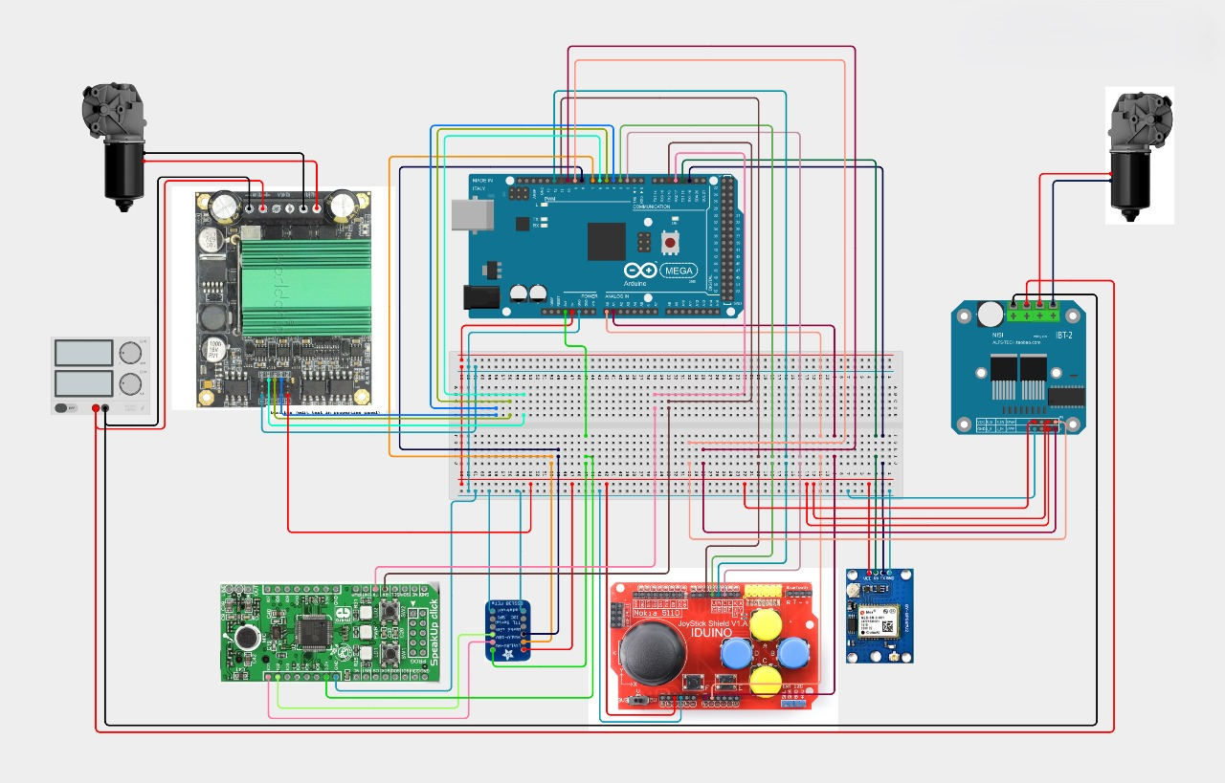

Figure 6 : Project Design

**Implementation (Hardware and Software):**

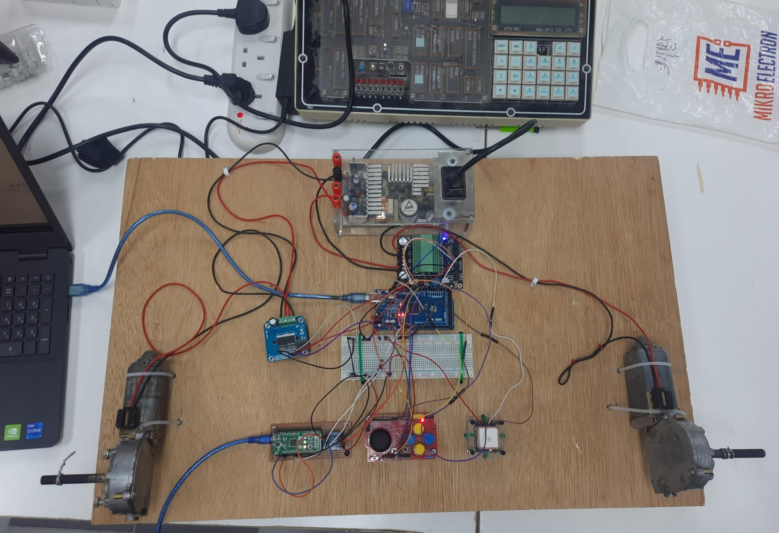

Figure 7 : Implementation

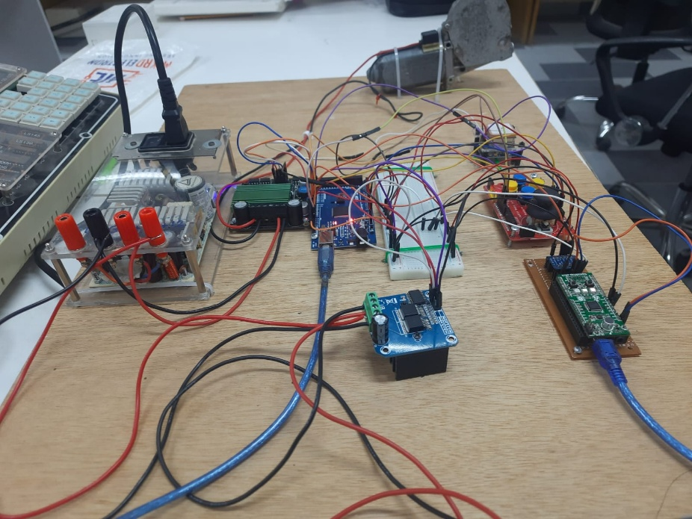

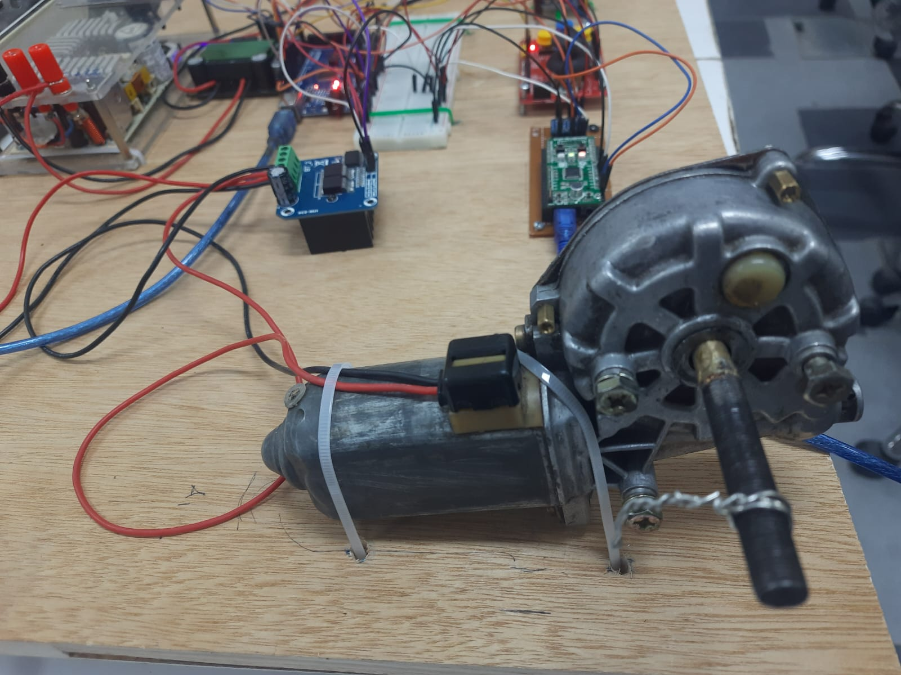

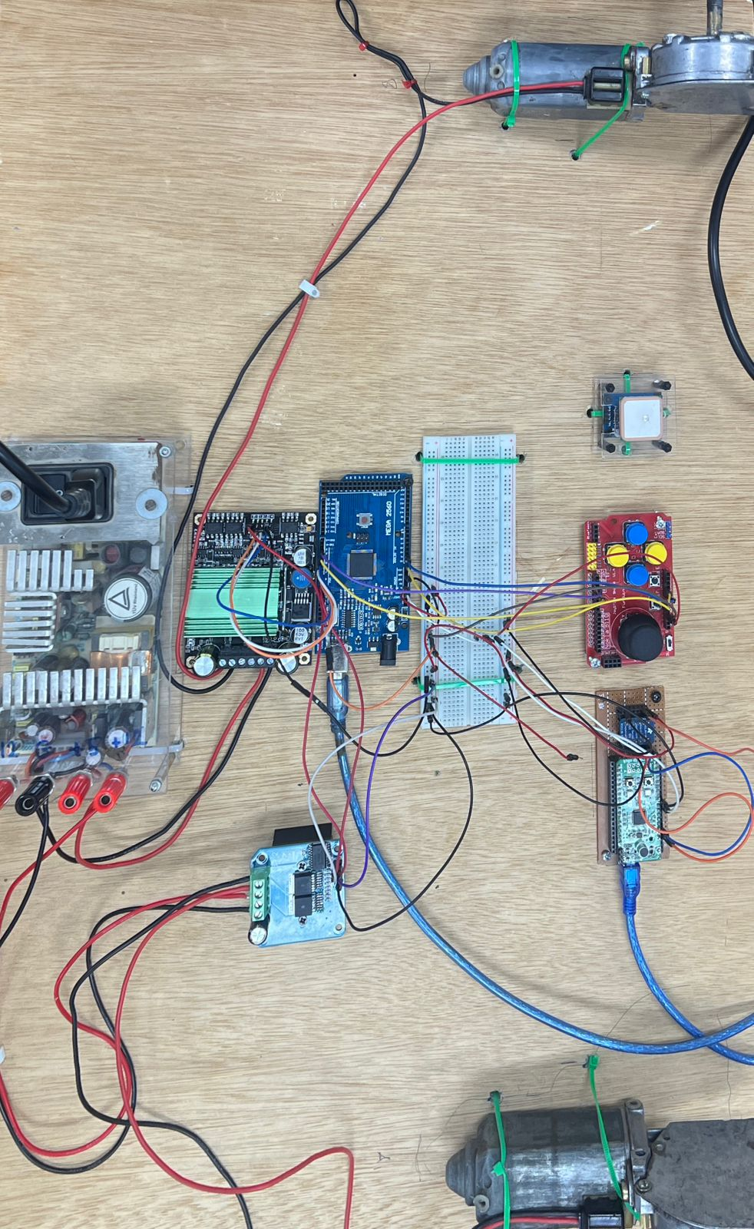

**Source Code :**

https://github.com/FerasBarahmeh/Graduation-Project/blob/main/GraduationProjectCode/GraduationProjectCode.ino

**Conclusion:**

This project successfully demonstrates the design and simulation of an Arduino Mega-based wheelchair control system. Integration of key components to enable efficient and user-friendly operation of a motorized wheelchair. The system includes:

**1**. Motor Drivers (IBT-2) to control the speed and direction of the wheelchair's DC motors, ensuring smooth and precise movement.

**2**. Joystick Module to provide the user with an intuitive control interface for maneuvering the wheelchair in different directions.

**3.** Communication Modules (e.g., GPS) to enable location tracking and navigation support for outdoor use.

**4**. Audio Processing Module (e.g., SpeakUp Click) to incorporate voice control, providing an alternative and accessible input method for users with limited mobility.

This project successfully integrates these components into a cohesive system, ensuring functionality, safety, and accessibility. The wiring and power management in the simulation are optimized to handle the various modules efficiently.

In conclusion, the simulated system demonstrates the feasibility of building a reliable and user-friendly motorized wheelchair. It offers flexibility for future improvements, such as adding advanced sensors for obstacle avoidance or connectivity features for remote monitoring and control, paving the way for enhanced mobility solutions for individuals with disabilities.

**References:**

[1] "Design of a Wheelchair for People with Disabilities Controlled by Head Movements," Damascus University.

<https://www.damascusuniversity.edu.sy>.

[2] "Ks0153 Keyestudio Joystick Shield," Keyestudio Wiki.

<https://wiki.keyestudio.com/Ks0153_keyestudio_JoyStick_Shield>.

[3] "Level Up Your Arduino with the Joystick Shield V2.4," All About Circuits.

<https://www.allaboutcircuits.com/projects/level-up-arduino-joystick-shield-v2.4/>.

[4] "Arduino Gamepad Joystick Shield," Art of Circuits.

<https://artofcircuits.com/product/arduino-gamepad-joystick-shield-1>.

[5]"SpeakUp Click Module", Mouser Electronics.

<https://www.mouser.com/datasheet/2/272/speakup-click-manual-v100-a-1483821.pdf>

[6] "Neo-6M GPS Module”, Last Minute Engineers.

https://lastminuteengineers.com/neo6m-gps-arduino-tutorial/

[7] "High Current Motor Driver IBT-2 Arduino," Lab Elektronika, 2016.

<https://www.labelektronika.com/2016/09/high-current-motor-driver-Ibt-2-arduino.html>.